**Q1) Pull any image from the docker hub, create its container, and execute it showing the output.**

**Docker pull:** The “docker pull” automatically pulls the image from the docker hub.

**Docker create:** This command will create a container if image exists in the client(local registry).

**Docker start:** docker start will run the container created by the create command.

**Docker run:** This command will perform all three operations together.When we use this command, it will pull the image from the client if exists, otherwise it will fetch the image from the dockerhub and creates a container from that image and executes the container and the output is screened to the terminal.

To perform any operations, first we need to install docker application and start it.To check whether we have installed docker or not we can use **docker version** command and it will display details about both the client and server.

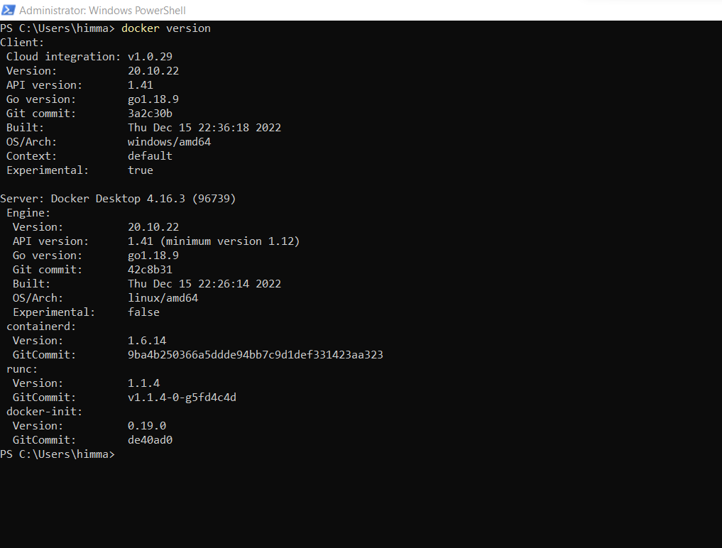

**To pull a image:**

**docker image pull <image-name>(recent preferred version) or**

**docker pull <image-name>**

**To create a container:**

**docker container create [options] --name containername imagename (or)**

**docker create [options] imageanme**

**To start a container:**

**docker container start [options] containername**

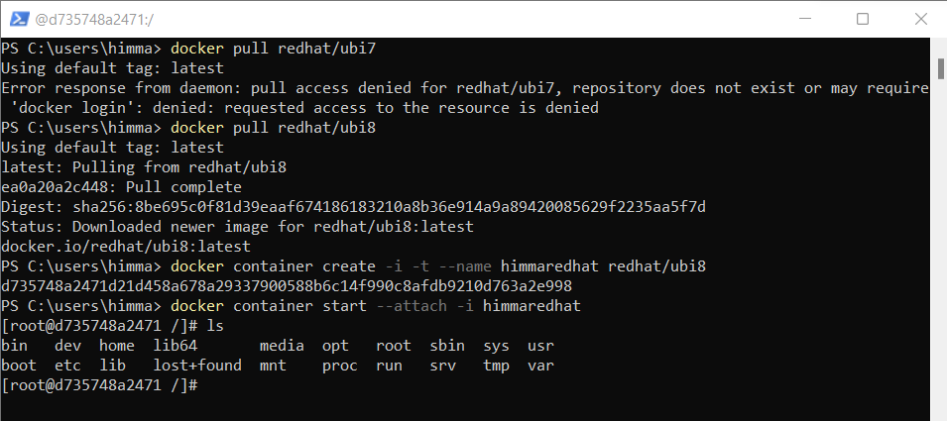

**Q2) Create the basic java application, generate its image with necessary files, and execute it with docker.**

To run a java application, we need to create a java file and a dockerfile in a same folder.

After creating the files navigate to that folder in powershell. [cd foldername ]

Then use docker build command to build the image from the dockerfile.

Syntax: **docker build .** [ “.” indicates to take the dockerfile in the current directory ].

Ex: docker build -t imagename .

Later run that container in interactive mode by specifying options -it

Ex: **docker run -it imagename**

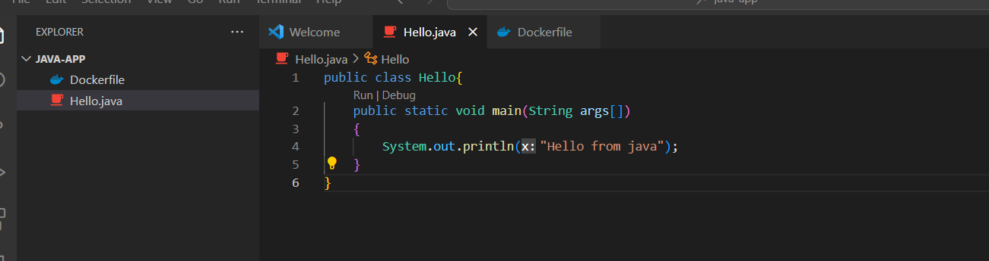

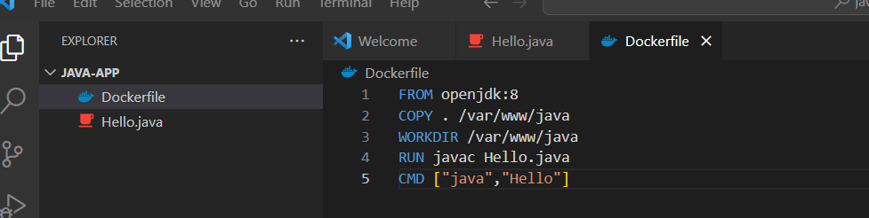

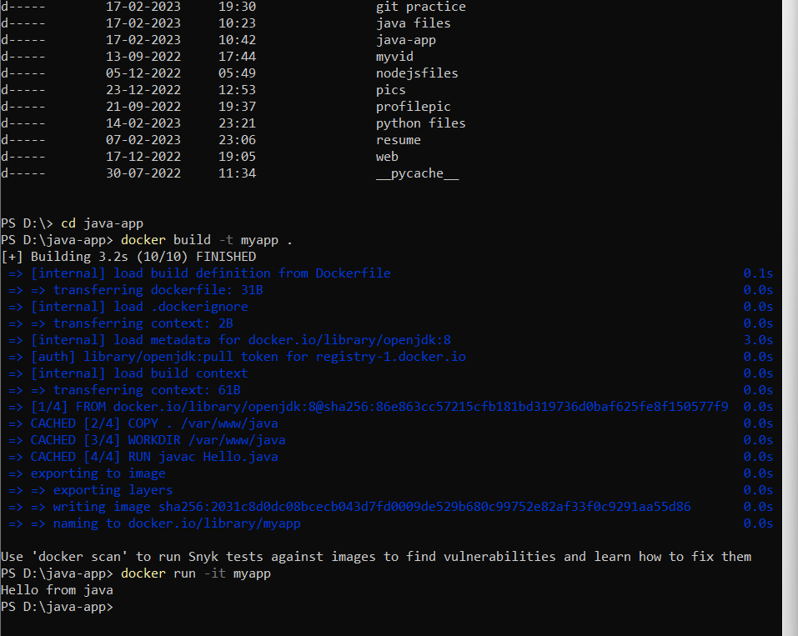

**Github link: https://github.com/Himmasri/assignments**